**Conceptual framework**

What is your conceptual framework?

* Can you produce a diagram of the process of your research?
* Can you produce a flowchart of your research, of how knowledge will be developed and how it will contribute to the field of study?

An example of a (generic) conceptual framework. 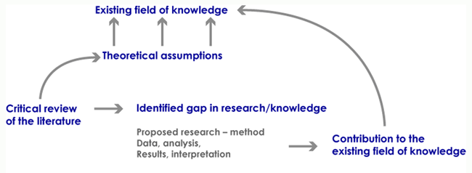

If we look at the project in the example above of developing research questions, the conceptual framework might look something like this:

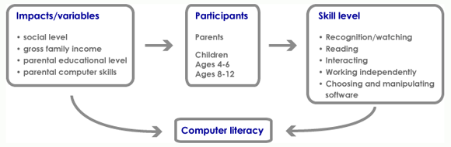

If we now add the theoretical component-the learning theory, we get something like this:

